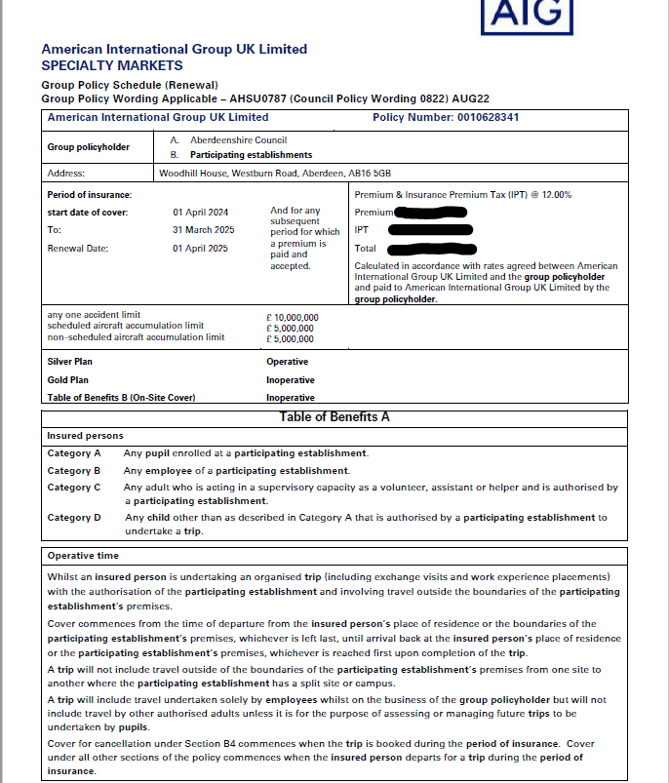

Emergency Assistance Helpline 01273 – 552922 (open 24hrs, 365 days a year)
This covers all types of emergency including the requirement for medical assistance, kidnap evacuation

